#include <iostream>
#include<bitset>
using namespace std;
int main(){
char a ='b';
char b ='d';
char c='f';
int d=3;
a>>=a<<(d^c);
b>>=a&~c;
cout<<bitset<8>(a)<<endl;
cout<<b<<endl;
cout<<c<<endl;
}
#include <iostream>
#include<math.h>
using namespace std;
int main()
{
double value1, value2, value3;
cout << "Enter a number: ";
cin >> value1;
value2 = 2 * (int)pow(value1, 2)%3;
value3 = 3 + value2 / 2 +4 * 5;
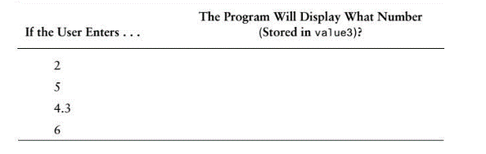
cout << value3;}
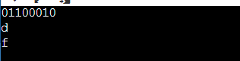
Solution 1

Solution 2
